My organization’s Mobile App

We have a surprise!
My organization is launching a mobile app
Use this template to create your own sponsorship brochure. Right click and save images to edit.
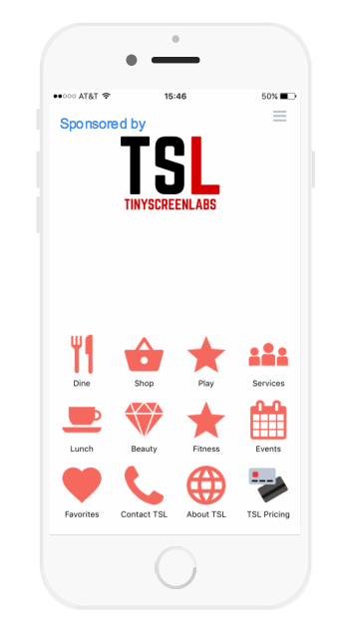
My organization’s mobile app, wherever you are, at a glance. Restaurants, bars, shops, services or events, with the app you can keep track of everything. With the Main Street app you can always know what is happening in the area. It contains detailed listings for each business in the community. Each listing comes with a description and information such as directions, hours of operation and special offers. The navigation is intuitive and clearly organized so that you can find what you are looking for easily and in a convenient format. Information is available online and offline.
The mobile app is yet another way for Main Street to engage with people who are lifelong residents as well as new visitors to our community.

$3000 Sponsorship includes
- Splash Screen
- Home Page Button
- Push Notifications

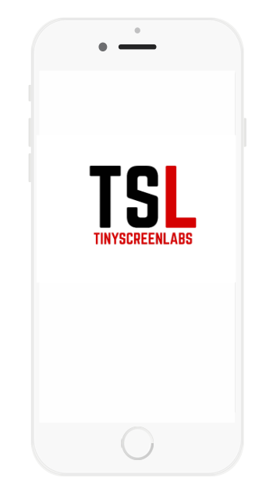

Splash Screen
High profile branding features your name and logo fullscreen when the app is loading. Get your name and brand in front of all users makes a strong first impression. The app is available for iPhone, iPad and Android.

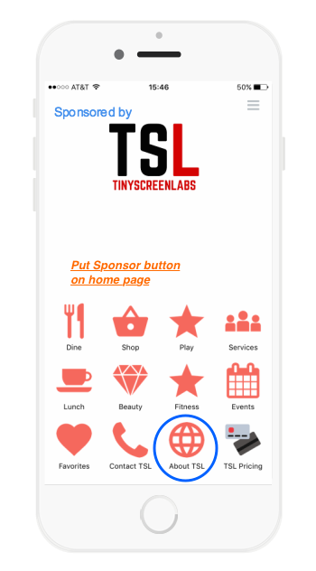
Home Page Button
High profile branding with a sponsor button on the home page linked to your website. Users can tap the button to see your website in the mobile app. Boost traffic to your website and increase visibility about what services and products you provide to new and existing customers.

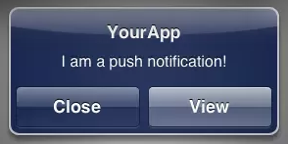
Push Notifications
Let’s you connect with users about your business. Main Street will send out 5 alerts and updates on your behalf. Alerts display at the top and center of mobile devices. Users receive messages as long as they have the app installed.

